**Map Key / Legend**

*For the Brown County Wisconsin Internet GIS site ( <http://maps.gis.co.brown.wi.us/geoprime/> )*

**Layers “on” by default**

Symbols used for the “Parcel Ownership”

(simple parcel boundaries):

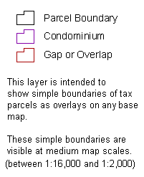

Symbols used for the “Parcels” layer

(detailed parcel lines):

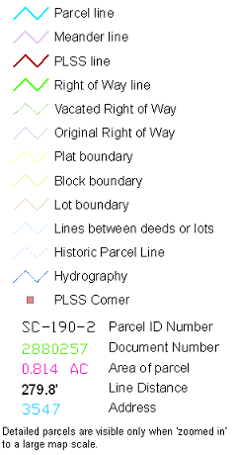







Symbols used for Transportation layers:

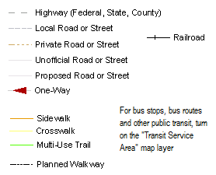

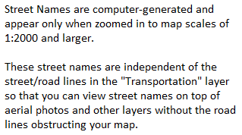

Hydrography (Lakes & Rivers):

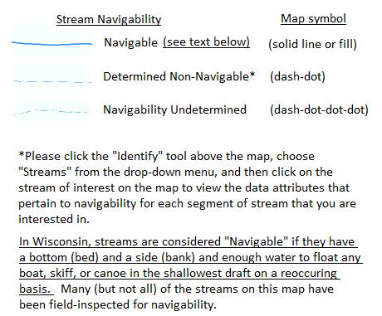

Wetlands (DNR)

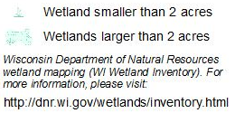

**Other layers that can be made visible using the “Layers” button**

To view these layers, click the  button (upper left side of the map) and check them “on”

**FEMA Floodplains**

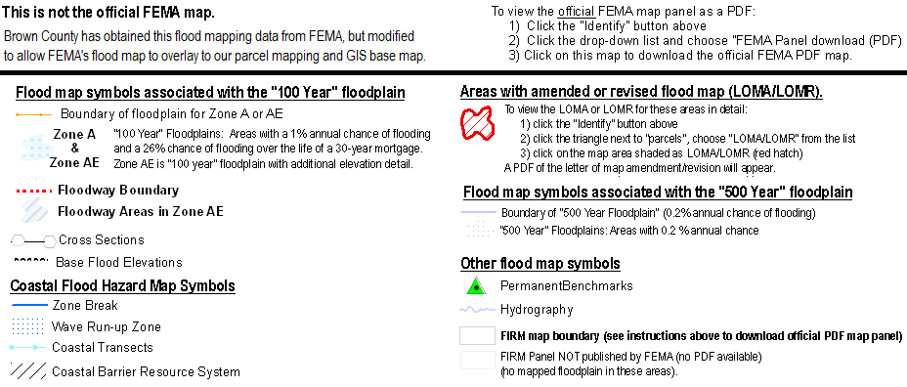

**­­­­­­­­­­­­­­­­­­­­­­__________________________________________________________________________________**

**Airport Zoning**

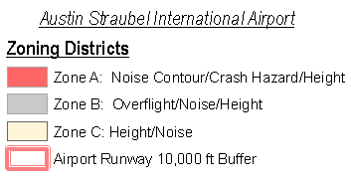

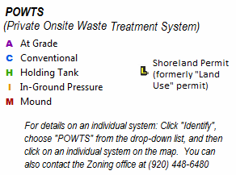

**Districts & Wards**

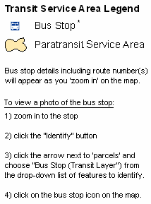

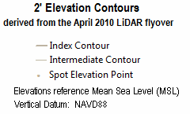

Soils (NRCS)

